Outputs for lab 4 submission

# Question 1:

Write a C program that takes two integer values as input from the user. Then swap the values taken from the user and display the output of the variables.

### Output:

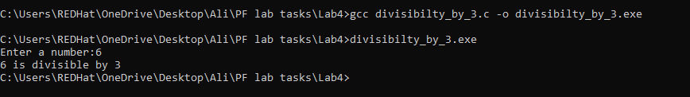

# Question 2:

### Create a calculator asking for operator (+ or – or * or /) and operands and performs calculation according to the user input using switch statement.

### Output:

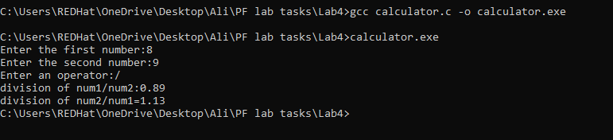

# Question 3:

### Write a C program to input a character from the user and check whether the given character is a small alphabet, capital alphabet, digit, or special character, using if else.

### Output:

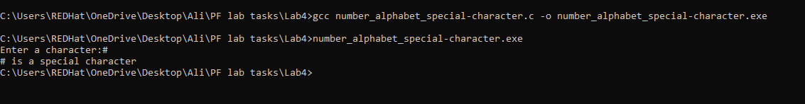

# Question 4:

### An online shopping store is providing discounts on the items due to Eid. If the cost of items is less than 2000 it will give a discount of up to 5%. If the cost of shopping is 2000 to 4000, a 10% discount will be applied. If the cost of shopping is 4000 to 6000, a 20% discount will be applied. If it’s more than 6000 then a 35% discount will be applied to the cost of shopping. Print the actual amount, saved amount and the amount after discount. The Minimum amount eligible for a discount is 500.

### Output:

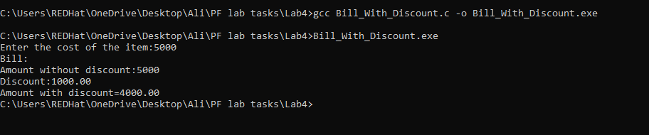

# Question 5:

Write a program in C to calculate and print the Electricity bill of a given customer. The customer id., name and unit consumed by the user should be taken from the keyboard and display the total amount to pay to the customer. The charges are as follow:

|  |  |
| --- | --- |
| Unit | Charge/Unit |
| Up to 199 | @16.20 |
| 200 and above but less than 300 | @20.10 |
| 300 and above but less than 500 | @27.10 |
| 500 and above | @35.90 |

If the bill exceeds Rs. 18000 then a surcharge of 15% will be charged on top of the bill.

### Output:

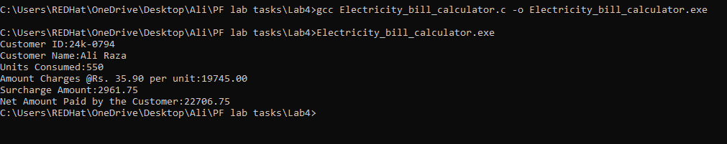

# Question 6:

Given a positive integer denoting n, do the following:

* 1. If 1<=n<=9, print lowercase English words corresponding to the numbers e.g. (one for 1, two for 2)
  2. If n>9 print greater then 9

### Output:

